**MINI PROJECT REPORT**

**ON**

**UNIT CONVERTER USING PYTHON**

Submitted by

**R.Dharini**

**Roll**

For

23CSE101-Computational Problem Solving

I Semester

B.Tech,CSE

**School of Computing**

**Amrita Vishwa Vidyapeetham, Nagercoil**

**Index**

**SI.NO Chapter Name Page No.**

1. Introduction

2. Problem Statement

3. Objectives

4. Python libraries used in the project

5. Modules of the project

6. Code

7. Output screenshots

8. Application of the project

9. Limitations of the project

10. Bibliography

11. Github link of the project

**Introduction**

Unit conversion is a fundamental task that is frequently required in various fields such as science, engineering, medicine, cooking, and even daily life. Different systems of measurement, such as the metric and imperial systems, use different units to quantify the same concepts, such as length, weight, temperature, and volume. For example, while kilometers are used to measure distance in many parts of the world, others may use miles. Similarly, temperature can be expressed in Celsius, Fahrenheit, or Kelvin depending on the context. Converting between these units accurately is crucial, especially in scientific and engineering applications, where even small errors in conversion can lead to significant problems.

Manually converting units can be tedious and error-prone, particularly when dealing with large numbers or complex calculations. With the rapid advancement of technology, automation of such tasks has become a necessity. The **Unit Converter** project is designed to address this need by providing an automated and easy-to-use tool for unit conversion. Developed in Python, this application simplifies the process by allowing users to convert between various units with just a few clicks.

The application uses Python's powerful capabilities and the Tkinter library to create a graphical user interface (GUI) that is both functional and intuitive. Users can select the type of conversion (such as length, temperature, or weight), enter the value they want to convert, and quickly obtain the result. By eliminating the need for manual calculations, this unit converter not only saves time but also ensures accuracy, making it an invaluable tool for professionals, students, and anyone who regularly needs to perform unit conversions.

**Problem statement**

Unit conversion is a crucial aspect of various domains, including science, engineering, cooking, travel, and everyday life. Different measurement systems, such as the metric and imperial systems, use different units to represent quantities like length, weight, temperature, and volume. For example, distances are measured in kilometers or miles, weights in kilograms or pounds, and temperatures in Celsius or Fahrenheit. Despite the widespread use of multiple unit systems, converting between them manually is often tedious, time-consuming, and prone to human error.

In many situations, incorrect unit conversion can lead to significant mistakes. For instance, an engineer working with measurements in construction might use the wrong unit conversion, leading to structural issues. A cook following a recipe from another country might make an incorrect conversion, ruining the dish. Similarly, travelers and researchers face difficulties when switching between unit systems.

The primary challenge addressed by this project is the need for an efficient, reliable, and easy-to-use tool that automates unit conversion. By creating a Python-based unit converter with an intuitive graphical user interface (GUI), this project aims to eliminate the possibility of manual errors and make unit conversions faster and more accessible to users from all backgrounds. The tool is designed to simplify conversions and ensure accuracy, supporting a wide range of units for various use cases.

**Objectives**

The Unit Converter project is designed with the goal of simplifying the process of converting units across different measurement systems. The key objectives of this project are outlined below:

1. User-Friendly Interface: One of the primary goals of this project is to provide a simple and intuitive graphical user interface (GUI) that users can easily navigate. The application will offer a clean, organized design that allows users to enter values, select the units they want to convert from and to, and display results quickly. The interface will be minimalistic yet informative, providing clear labels, buttons, and dropdown menus. By ensuring that the tool is easy to use, even individuals with no technical background can perform unit conversions without difficulty.
2. Accurate Conversion: The core purpose of the project is to ensure accuracy in the unit conversion process. The unit converter will be designed to use precise mathematical formulas to convert between units of measurement. Whether converting kilometers to miles, Celsius to Fahrenheit, or kilograms to pounds, the tool will provide accurate results based on reliable conversion factors. Accuracy is crucial in fields like engineering, science, and cooking, where incorrect conversions could lead to significant errors or failures.
3. Comprehensive Unit Support: The unit converter will support a wide range of units from different categories, including length, temperature, and weight. Initially, the tool will support a limited selection of commonly used units (such as kilometers, miles, Celsius, Fahrenheit, kilograms, and pounds), but it will be designed to accommodate additional units in the future. This versatility allows the tool to be applicable in many different scenarios, whether for academic purposes, professional work, or personal use.
4. Robust Error Handling and Input Validation: The project will include robust validation mechanisms to ensure that the data entered by the user is valid and correct. For example, if a user tries to input a non-numeric value or leaves a required field blank, the program will alert the user and prompt them to correct the input. This minimizes the chances of errors, enhancing the user experience and preventing the application from crashing due to invalid input. The tool will handle errors gracefully, providing helpful feedback to the user without interrupting the conversion process.
5. Scalability and Extensibility: One of the long-term goals of the project is to create a scalable tool that can easily be expanded to support additional units and measurement categories. The architecture of the unit converter will be modular, making it straightforward to add new conversions (such as time, volume, or pressure) in the future. This extensibility ensures that the application can continue to meet the growing needs of users, whether they are students, professionals, or hobbyists.
6. Efficiency and Speed: The tool aims to provide fast and efficient unit conversions. By automating the process, users can instantly get the result without needing to manually calculate conversions. The speed of conversion, especially for large values or multiple conversions, will be optimized to ensure that the tool remains responsive even when handling complex input.

These objectives collectively aim to create a Unit Converter tool that is not only accurate and efficient but also easy to use and flexible enough to accommodate future expansions. The project strives to make unit conversion more access**ible.** and reliable for a wide range of users.

**Python libraries used**

The **Unit Converter** project leverages Python’s powerful libraries to ensure smooth functionality, efficient performance, and an intuitive user experience. Below are the key libraries used:

**1. Tkinter:**

Tkinter is the standard Python library for creating graphical user interfaces (GUIs). It provides all the necessary tools to build windows, buttons, labels, input fields, dropdown menus, and other interactive elements that form the backbone of the application’s user interface. Tkinter allows for quick development of simple and intuitive desktop applications. In this project, Tkinter is used to design the GUI, making the application visually accessible and easy to navigate. The input fields and dropdown menus for unit selection are created using Tkinter widgets, while the result display section is also managed through this library. Tkinter’s simplicity and flexibility make it an ideal choice for building lightweight, functional desktop applications.

**2. math:**

The math library is used for performing mathematical operations that might be needed for more complex conversions. While this project primarily uses direct unit conversion formulas, the math library offers various mathematical functions (e.g., square root, trigonometric operations) that can be useful if the tool is expanded in the future to handle more complex conversions. For now, it may be employed to ensure that any mathematical operations required for unit conversion are performed accurately and efficiently.

**3. sys:**

The sys library provides access to system-specific parameters and functions. In this project, sys is mainly used for handling errors and managing the flow of the program. For instance, if the application encounters an unexpected error or an invalid input that it cannot handle, sys can help gracefully terminate the program or display an appropriate message to the user without causing the program to crash. This library ensures that the unit converter operates smoothly, even when it encounters edge cases or input errors.

Together, these libraries provide the necessary components for building the **Unit Converter** project, with Tkinter handling the GUI, math handling any mathematical computations, and sys managing error handling and system-level operations.

**Modules of the project**

The **Unit Converter** project is structured into several well-defined modules, each serving a distinct function. This modular approach ensures that the code remains clean, maintainable, and easy to extend as new features or unit categories are added. Below is a detailed breakdown of the key modules that make up the project:

**1. Main GUI Module:**

The **Main GUI Module** is responsible for creating and managing the graphical user interface (GUI) of the unit converter. This module is built using Python’s Tkinter library, which provides a wide range of widgets and tools to create user-friendly interfaces. It includes all visual elements such as input fields, dropdown menus, labels, buttons, and display areas. The module manages the window layout, positioning of elements, and overall look and feel of the application.

* **Input Fields**: Users enter the value they wish to convert into input fields. These fields are validated by the error handling module to ensure the data is in the correct format.
* **Dropdown Menus**: These allow users to select the units they want to convert from and to (e.g., kilometers to miles, Celsius to Fahrenheit). The dropdown menu makes it easy for users to select the desired unit.
* **Action Buttons**: Buttons like "Convert" trigger the conversion process, and others such as "Clear" or "Exit" help with clearing the input fields or closing the application.
* **Result Display**: The converted result is displayed dynamically, providing users with immediate feedback.

The main GUI module acts as the interface through which users interact with the application. It also communicates with the conversion logic module to obtain results and display them in real-time.

**2. Unit Conversion Logic Module:**

The **Unit Conversion Logic Module** is the heart of the unit converter application. This module contains all the functions and formulas necessary to perform the actual unit conversions. Based on the input value and selected units, this module calculates and returns the correct conversion result. The module is designed to handle multiple types of conversions, including:

* **Length**: This includes conversions between units like kilometers, miles, meters, feet, inches, etc.
* **Temperature**: Conversions between Celsius, Fahrenheit, and Kelvin.
* **Weight**: Conversions between kilograms, pounds, ounces, and grams.

Each conversion type has its own set of formulas. For example, the formula to convert Celsius to Fahrenheit is:

Fahrenheit=(95×Celsius)+32\text{Fahrenheit} = \left( \frac{9}{5} \times \text{Celsius} \right) + 32Fahrenheit=(59​×Celsius)+32

The conversion logic module ensures that the correct formula is applied based on the units selected by the user. The module also supports conversions from any unit in the category to any other unit (e.g., kilometers to miles, miles to meters), ensuring flexibility.

This module can be easily expanded to include additional unit categories such as **volume**, **time**, or **pressure**, making it scalable as the project grows.

**3. Error Handling Module:**

The **Error Handling Module** is crucial for ensuring the robustness and reliability of the application. This module performs input validation to ensure that users provide valid values for conversion. It checks for several possible errors and handles them appropriately:

* **Non-Numeric Input**: If the user enters a non-numeric value (e.g., letters or symbols) in the input field, the program will display an error message and prompt the user to correct it.
* **Empty Fields**: If the user leaves the input field blank or fails to select both the source and target units, the application will notify the user and prevent the conversion process from proceeding.
* **Invalid Unit Selection**: If the user tries to convert between incompatible units (e.g., converting kilograms to temperature), the program will alert the user and prevent the operation.

This module ensures that the program doesn't crash due to invalid inputs and helps maintain a smooth user experience. It also provides helpful error messages that guide the user in correcting their input.

**4. Helper Functions Module:**

The **Helper Functions Module** contains various utility functions that assist the other modules in performing their tasks more efficiently. Some of the key helper functions include:

* **Input Formatting**: This function ensures that the input values are formatted correctly (e.g., removing extra spaces or converting values to the appropriate data type, like float).
* **Output Formatting**: After the conversion, this function ensures that the output result is displayed in a user-friendly format (e.g., rounding off to two decimal places).
* **Unit Conversion Data**: This function stores and retrieves the conversion factors needed for calculations, such as the conversion rate between kilometers and miles, or Celsius to Fahrenheit.
* **Clearing Fields**: This function resets the input fields and output result areas, allowing the user to perform another conversion without manually clearing previous data.
* **Conversion History (optional)**: This function could store a log of previous conversions, allowing users to refer back to them if needed.

These helper functions streamline the conversion process and enhance the overall user experience by automating repetitive tasks and ensuring consistency across different parts of the application.

**5. Logging and Debugging Module (optional):**

For larger applications, a **Logging and Debugging Module** might be included to track the application’s behavior, log errors, and monitor performance. This module helps developers troubleshoot any issues that arise during the development or after deployment. It can log events like invalid inputs, errors during conversions, or system crashes.

* **Logging**: This function can record events that provide insights into the application's flow, such as when a conversion is requested or when an error occurs.
* **Debugging**: If an error is encountered, this module helps identify the exact line or operation that caused it, making it easier for developers to debug and fix issues.

**6. Unit Test Module (optional):**

A **Unit Test Module** can be used to ensure that all functions in the program work correctly. Unit tests are automated tests that check the functionality of each individual unit (or module) in the application. This module would contain test cases to verify that the unit conversion formulas work as expected, that the input validation is correct, and that the GUI behaves properly under different scenarios.

* **Test Case for Conversion**: It would verify that converting 1 kilometer to miles gives the expected result of 0.621371.
* **Test Case for Validation**: It would ensure that an invalid input (e.g., a string instead of a number) triggers the appropriate error message.

These modules work together to provide a seamless experience for the user, ensuring that the application is not only efficient and easy to use but also reliable and maintainable. The modular structure also makes it easier to expand the tool, whether by adding new units, categories, or additional features in the future.

**Code**

import tkinter as tk

from tkinter import ttk

from tkinter import messagebox

# Conversion logic

def convert_units():

try:

value = float(entry_value.get())

from_unit = combo_from.get()

to_unit = combo_to.get()

conversions = {

'kg': 1000, # kilograms to grams

'g': 1, # grams

'l': 1000, # liters to milliliters

'ml': 1, # milliliters

'cm': 0.01, # centimeters to meters

'm': 1 # meters

}

if from_unit not in conversions or to_unit not in conversions:

raise ValueError("Invalid units selected.")

base_value = value * conversions[from_unit] # Convert to base unit

result = base_value / conversions[to_unit] # Convert to target unit

label_result.config(text=f"Result: {value} {from_unit} = {round(result, 4)} {to_unit}")

except ValueError:

messagebox.showerror("Error", "Please enter a valid number and select proper units.")

# Create the main window

root = tk.Tk()

root.title("Unit Converter")

root.geometry("400x400")

root.resizable(False, False)

root.config(bg="#f0f8ff")

# Title label

label_title = tk.Label(root, text="Unit Converter", font=("Arial", 20, "bold"), bg="#f0f8ff", fg="#007BFF")

label_title.pack(pady=20)

# Input value

frame_input = tk.Frame(root, bg="#f0f8ff")

frame_input.pack(pady=10)

label_value = tk.Label(frame_input, text="Enter Value:", font=("Arial", 12), bg="#f0f8ff")

label_value.grid(row=0, column=0, padx=10, pady=10)

entry_value = tk.Entry(frame_input, font=("Arial", 12))

entry_value.grid(row=0, column=1, padx=10, pady=10)

# From unit selection

frame_units = tk.Frame(root, bg="#f0f8ff")

frame_units.pack(pady=10)

label_from = tk.Label(frame_units, text="From Unit:", font=("Arial", 12), bg="#f0f8ff")

label_from.grid(row=0, column=0, padx=10, pady=10)

combo_from = ttk.Combobox(frame_units, values=["kg", "g", "l", "ml", "cm", "m"], font=("Arial", 12))

combo_from.grid(row=0, column=1, padx=10, pady=10)

combo_from.set("kg") # Default selection

# To unit selection

label_to = tk.Label(frame_units, text="To Unit:", font=("Arial", 12), bg="#f0f8ff")

label_to.grid(row=1, column=0, padx=10, pady=10)

combo_to = ttk.Combobox(frame_units, values=["kg", "g", "l", "ml", "cm", "m"], font=("Arial", 12))

combo_to.grid(row=1, column=1, padx=10, pady=10)

combo_to.set("g") # Default selection

# Convert button

button_convert = tk.Button(root, text="Convert", font=("Arial", 14), bg="#007BFF", fg="white", command=convert_units)

button_convert.pack(pady=20)

# Result label

label_result = tk.Label(root, text="Result:", font=("Arial", 14), bg="#f0f8ff", fg="black")

label_result.pack(pady=10)

# Run the Tkinter event loop

root.mainloop()

**Output screenshots**

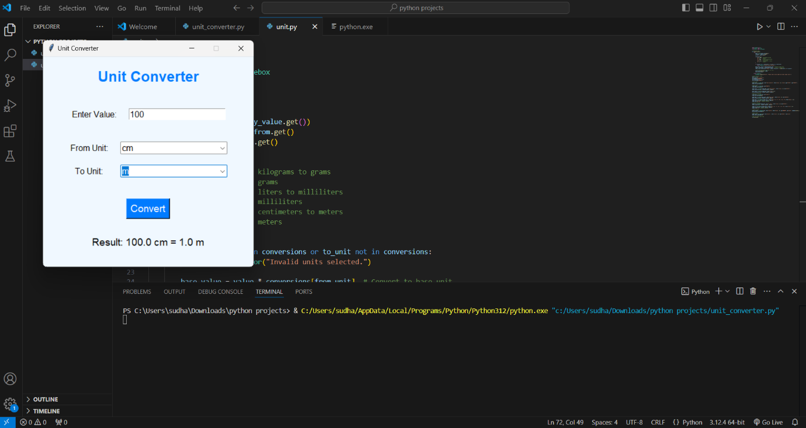

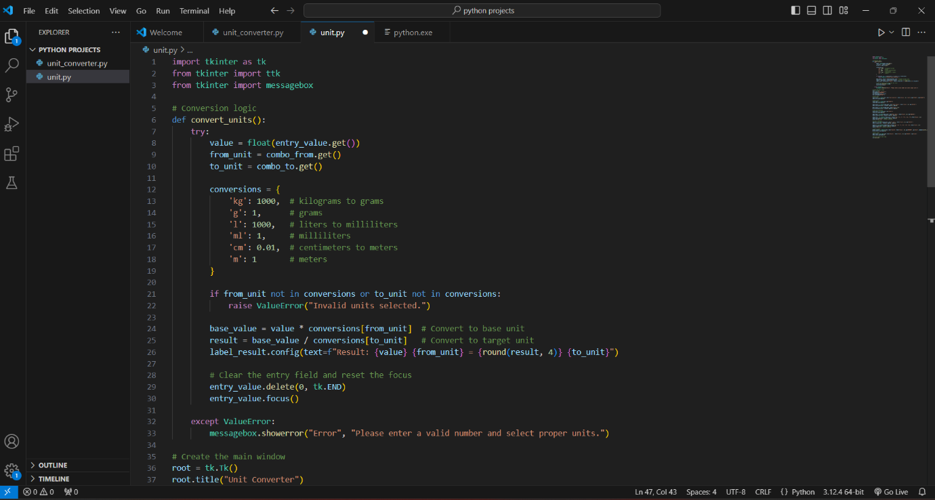

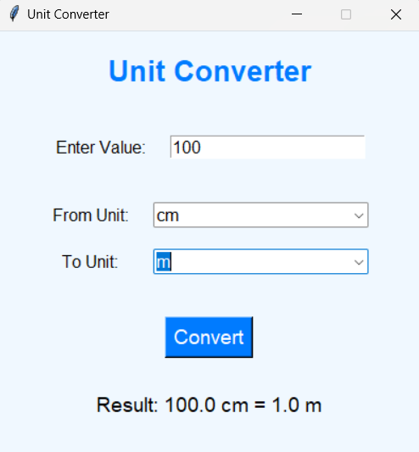

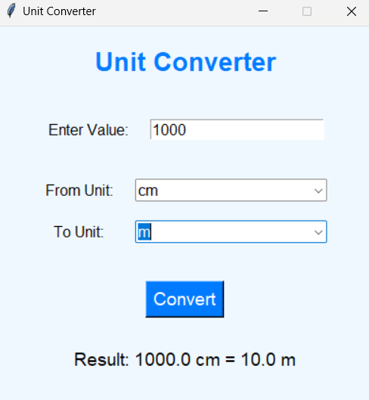

**Application of the project**

The **Unit Converter** built using Python has a wide range of applications across different fields. Its simplicity and versatility make it useful in both professional and everyday contexts. Below are some of the key areas where this unit converter can be applied:

**1. Engineering and Scientific Applications:**

Engineers, scientists, and researchers often work with measurements across different units. For instance, a civil engineer might need to convert between kilometers and miles, while a physicist may need to convert Celsius to Kelvin. The unit converter simplifies the process of switching between different unit systems, ensuring that the conversions are accurate and consistent. This tool is especially useful in fields such as **mechanical engineering**, **electrical engineering**, **chemistry**, and **physics**, where precise unit conversions are vital for experiments, calculations, and project design.

**2. Education:**

In educational settings, students and teachers frequently need to convert units in subjects like **mathematics**, **science**, and **geography**. This unit converter can be an invaluable learning tool, helping students understand and practice unit conversion with ease. Teachers can use it in classrooms to demonstrate real-time conversions, and students can use it for homework and assignments that require converting between various units. It can also assist in standardized test preparation, especially in exams that involve measurements and conversions.

**3. Cooking and Culinary Arts:**

Many recipes from different countries use different measurement systems. A recipe in the United States might measure flour in cups, while a recipe in Europe might use grams. The unit converter can easily convert between common cooking measurements, such as cups to milliliters, ounces to grams, or Fahrenheit to Celsius for cooking temperatures. It helps chefs and home cooks alike adapt recipes and ensure that ingredients are used in the correct proportions, regardless of the measurement system.

**4. Travel and Navigation:**

Travelers often encounter the need to convert units when moving between countries that use different systems of measurement. For example, distance might be measured in kilometers in one country and miles in another, or temperature may need to be converted from Celsius to Fahrenheit depending on the country. A **unit converter** can be particularly useful for travelers in managing distances, speed limits, weight for baggage, or temperature. It can also assist in converting time zones when traveling across regions, ensuring better trip planning.

**5. E-commerce and Retail:**

E-commerce platforms and international retailers that operate globally often deal with different unit systems for product measurements. For example, the size of a product might be listed in **inches** in the United States, while European buyers expect the measurement in **centimeters**. A unit converter can streamline this process by helping businesses quickly convert product dimensions, weight, or volume to match the regional units of customers. Similarly, it can assist in converting currency or shipping measurements for logistics purposes.

**6. Health and Medicine:**

In healthcare, accurate unit conversion is critical, especially when dealing with prescriptions, dosage instructions, and medical equipment measurements. For example, converting weight units (kilograms to pounds), volume units (milliliters to fluid ounces), or temperature units (Celsius to Fahrenheit) is essential when documenting patient information or preparing medication dosages. A **unit converter** can also help healthcare professionals working internationally or with medical literature from different regions that use different units of measurement.

**7. Environmental Science and Sustainability:**

Environmental scientists working in areas like **climate change**, **pollution control**, and **resource management** often need to perform conversions related to temperature, energy, and distance. For instance, converting energy consumption measurements from kilowatt-hours to joules, or emissions measurements from grams per kilometer to pounds per mile, might be needed for analysis or reporting. A **unit converter** can be an essential tool for those in this field to accurately assess and communicate data across different measurement standards.

**8. Construction and Architecture:**

In the construction industry, accurate unit conversions are required for tasks like estimating material quantities, measuring land areas, and designing structures. Architects and builders often need to convert between metric and imperial systems when working with blueprints, specifications, and construction standards. For example, converting meters to feet, square meters to square feet, or cubic meters to cubic yards is common in daily construction activities. The unit converter simplifies these conversions and helps prevent measurement errors that could lead to costly mistakes in projects.

**9. Software Development and Automation:**

Programmers, especially those working on software that deals with data input or data visualization, may need to handle different unit systems in applications. A unit converter can be used as a **backend tool** for applications that require unit conversion, such as those used in finance, engineering, or scientific research. By integrating the unit conversion functionality into other software systems or automating processes that require conversions (such as real-time unit conversions in engineering simulations), this tool can make workflows more efficient.

**10. Personal Use:**

On a day-to-day basis, individuals can use the unit converter for tasks like converting travel distances, temperature changes, or shopping measurements. Whether it’s understanding cooking recipes from a different country, tracking personal fitness data (like converting pounds to kilograms), or simply converting measurements for DIY projects around the house, this tool offers a convenient solution to handle unit conversions quickly and accurately.

Overall, the **Unit Converter** project has a broad scope of applications in multiple domains, making it a highly practical and versatile tool. It serves as an invaluable resource for professionals, students, travelers, and everyday users, helping them bridge the gap between different unit systems with ease and accuracy.

Top of Form

**Limitations of the project**

While the **Unit Converter** project is designed to be a helpful tool for a wide range of applications, it does have several limitations that should be acknowledged. These limitations primarily stem from the scope of the project, the technology used, and the nature of unit conversions. Below are the key limitations:

**1. Limited Unit Categories:**

The current version of the **Unit Converter** focuses on a limited set of unit categories, such as **length**, **weight**, and **temperature**. While these are some of the most commonly used conversions, the tool does not support other measurement categories, such as **volume**, **time**, **speed**, or **pressure**. As the project evolves, additional categories can be added, but the current scope restricts its utility for users who need to convert in other fields.

**2. No Support for Complex Conversions:**

The tool is designed to handle basic conversions based on predefined formulas. However, it does not support more complex unit conversions that involve multiple steps or intermediate calculations. For instance, converting currency or converting between units that require adjusting for different standards (such as conversion factors that change over time or based on location) is not covered in this version.

**3. No Real-Time Data Integration:**

The current version of the project does not integrate with real-time data sources. For example, if the tool were to handle currency conversion, it would need access to live exchange rates. Similarly, conversions based on real-time data (like temperature or pressure) are not supported. The project relies on static conversion formulas, which limits its functionality in situations requiring dynamic or up-to-date information.

**4. Accuracy Issues with Approximation:**

Some conversions involve approximations. For instance, when converting between miles and kilometers, while the conversion factor (1 mile = 1.60934 kilometers) is quite accurate, there may be minor rounding errors when dealing with very large or very small numbers. This limitation, though not significant for most everyday conversions, could be problematic for highly precise scientific or engineering work where exact measurements are required.

**5. Lack of Multi-Language Support:**

The tool is currently designed in English, and the user interface does not support multiple languages. Users who are not familiar with English might face difficulties in understanding the interface and using the tool. Multi-language support could improve accessibility for a broader global audience, but this feature is not included in the current version of the project.

**6. No Mobile Support:**

The current version of the **Unit Converter** is designed as a desktop application and does not support mobile platforms. While Python libraries like Kivy can be used to develop cross-platform applications, the tool does not currently offer a mobile version. Users who prefer to access the unit converter on smartphones or tablets may find this a limitation.

**7. Fixed Conversion Factors:**

The tool uses fixed conversion factors for all calculations. While this works well for most standard conversions, it does not account for cases where conversion factors may vary depending on specific conditions. For example, temperature conversion might require adjustments in certain scientific contexts, or weight conversions might vary slightly depending on the material being measured (e.g., converting between kilograms and pounds for different substances). The tool currently lacks the flexibility to handle these more specific cases.

**8. No Support for Unit Prefixes:**

The current version of the **Unit Converter** does not handle unit prefixes like kilo (k), mega (M), milli (m), or micro (μ). Many fields, such as electronics or computing, require conversions between large and small units that are prefixed with such symbols. Adding the ability to convert units like kilobytes to megabytes or millimeters to micrometers would increase the tool’s versatility.

**9. No Conversion History or Memory:**

The project does not store a history of past conversions. For users who need to keep track of multiple conversions or use the tool repeatedly over a period of time, the lack of a memory or history feature can be inconvenient. This feature could be added to future versions to improve user experience, especially for those who need to make multiple conversions in one session.

**10. Static User Interface:**

The user interface (UI) built with Tkinter is relatively basic and static. While functional, the design does not support advanced features like **drag-and-drop** or interactive visualizations, which could enhance user engagement. The project does not incorporate modern UI frameworks or more dynamic features such as animations or real-time feedback.

**11. Limited Error Handling:**

Although basic error handling is implemented, the tool might still run into issues when dealing with very large numbers, incorrect data types (e.g., text input instead of numbers), or unexpected user behaviors. More advanced validation and error management techniques could be incorporated in future versions to handle edge cases more gracefully.

**12. No Unit Customization:**

The tool does not allow users to define custom units or conversion factors. For example, in some specialized fields, users may need to define their own measurement units or conversion factors. The lack of customization limits the tool’s flexibility for users with specific or uncommon needs.

**13. Not Optimized for Large-Scale Operations:**

The unit converter is designed to handle a limited number of conversions at a time. If users wish to perform bulk conversions (e.g., converting large datasets of measurements), the application may not be efficient enough. The program is not optimized for handling large-scale data operations, making it less suitable for industries or research areas where batch conversions are common.

In conclusion, while the **Unit Converter** project is a simple and effective tool for basic unit conversions, it has several limitations that prevent it from being fully scalable, dynamic, or suited for highly specialized applications. Future enhancements could address these limitations, making the tool more versatile and user-friendly across various domains.

Top of Form

Bottom of Form

**Bibliography**Bottom of Form

1. **Python Software Foundation.** (2024). *Python 3 Documentation*. <https://docs.python.org/3/>
   * The official Python documentation, which provides detailed information on the Python programming language, including libraries used for developing the Unit Converter project such as Tkinter and standard math operations.
2. **Tkinter Documentation.** (2024). *Tkinter - Python Interface to the Tk GUI Toolkit*. <https://docs.python.org/3/library/tkinter.html>
   * This resource covers the Tkinter library, which was used for creating the graphical user interface (GUI) of the Unit Converter project.
3. **Pardee, L.** (2017). *Python Programming for the Absolute Beginner* (3rd ed.). Cengage Learning.
   * A book that serves as a helpful guide for beginners learning Python programming. It provided foundational concepts that were applied to the development of the Unit Converter project.
4. **GeeksforGeeks.** (2024). *Unit Conversion in Python*. https://www.geeksforgeeks.org/unit-conversion-in-python/
   * This article provided insights into how unit conversion can be efficiently implemented using Python, including some basic formulas and techniques.
5. **Stack Overflow Community.** (2024). *Stack Overflow Questions on Unit Conversion and Tkinter*. <https://stackoverflow.com/>
   * A valuable resource for troubleshooting specific coding challenges and learning from the Python developer community. Various threads helped resolve specific issues related to Tkinter UI elements and unit conversion logic.
6. **W3Schools.** (2024). *Python Tkinter Tutorial*. https://www.w3schools.com/python/python_gui.asp
   * A tutorial website that provided a clear guide for implementing Python’s Tkinter library to build graphical user interfaces.
7. **Python for Data Science Handbook.** (2016). *Jake VanderPlas*. O'Reilly Media.
   * Although this book is primarily about data science, it offers useful insights into working with Python and handling numerical operations, which were important for implementing unit conversion formulas in the project.
8. **Hunt, M., & Thomas, D.** (2000). *The Pragmatic Programmer: Your Journey to Mastery*. Addison-Wesley.
   * A highly influential book on software development that provided programming best practices and guidelines that were useful for writing clean, efficient Python code in the Unit Converter project.
9. **Khan Academy.** (2024). *Unit Conversion in Mathematics*. <https://www.khanacademy.org/math>
   * This educational platform helped provide the mathematical principles behind the conversion formulas (e.g., Celsius to Fahrenheit, kilometers to miles).
10. **Wikipedia Contributors.** (2024). *Unit Conversion*. Wikipedia, The Free Encyclopedia. <https://en.wikipedia.org/wiki/Unit_conversion>

* This Wikipedia page provides a broad overview of unit conversion, including common conversions and their applications, which served as a reference for expanding the conversion categories in the project.

**Github link of the project**